**Final Project**

| **Project Title** | Predicting Customer Churn in Telecom Industry using Power BI or Tableau and SQL |
| --- | --- |
| **Skills take away From This Project** | **Power BI, Tableau and SQL** |
| **Domain** | **Telecom** |

**Problem Statement:**

### Predicting Customer Churn in Telecom Industry

### **Business Use Cases:**

1. **Customer Retention**: Identify at-risk customers and proactively implement retention strategies.
2. **Marketing Campaigns**: Tailor marketing efforts towards customers who are more likely to churn.
3. **Service Improvement**: Analyze churn patterns to improve service offerings and customer support.
4. **Revenue Optimization**: Reduce churn rates to maintain a steady revenue stream.

**Customer Segmentation**: Segment customers based on churn probability to offer personalized experiences.

**1. Data Preprocessing Documentation**

**1.1 Checking Data type of each column**

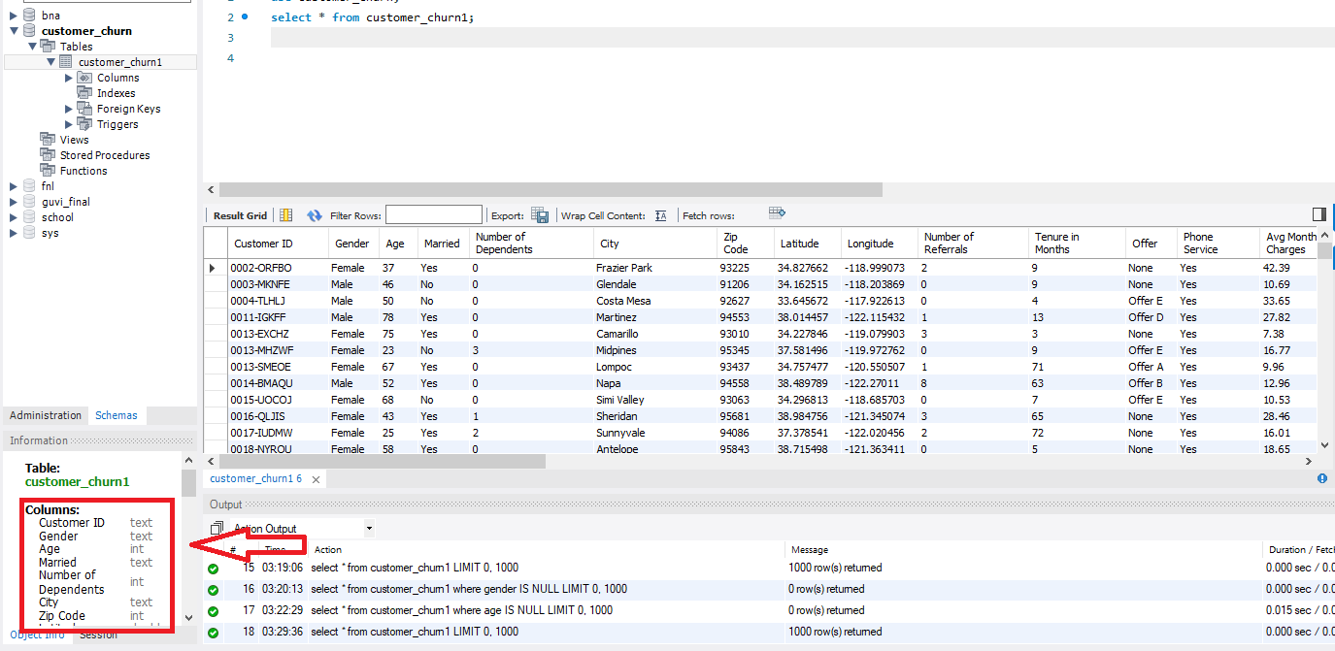

**1.2 Remove any duplicate entry in customer id**

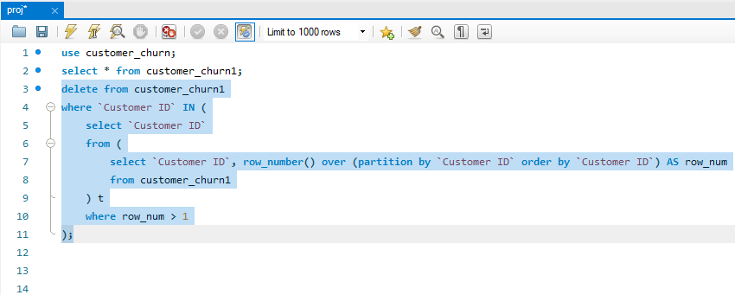

1.3 **Missing Values**

1. Delete NULL value from Customer ID

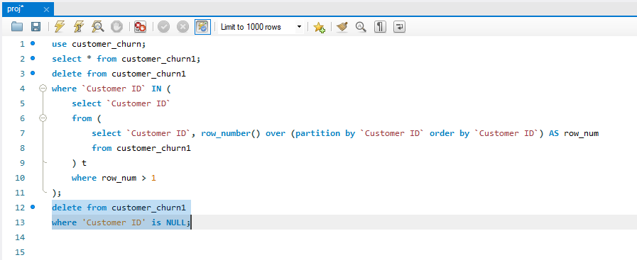

2. Update “NILL” for blank cells churn category, churn reason

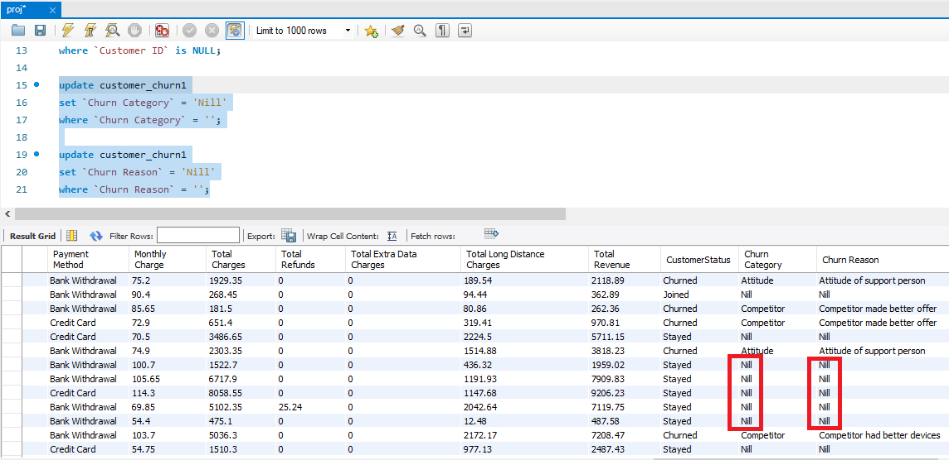

**1.4 Negative values in Monthly charge, monthly charge should not be negative, change it to positive value.**

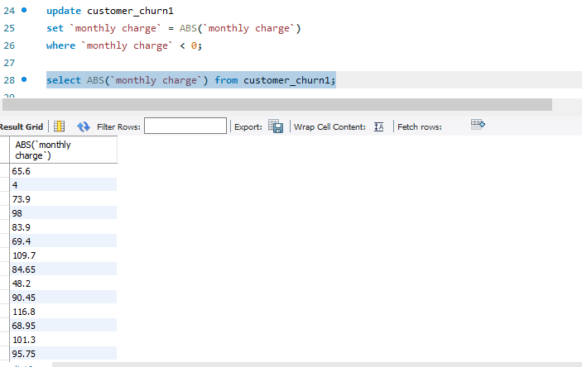

**Reports: Question & Answer**

**Ques1.** Identify the total number of customers and the churn rate

Count total number of customers

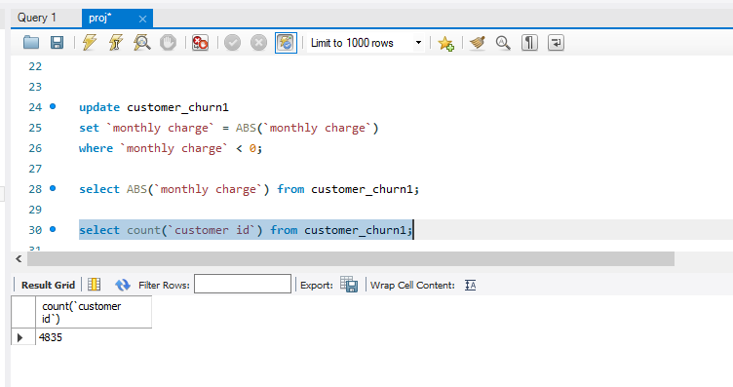

Find the Churn rate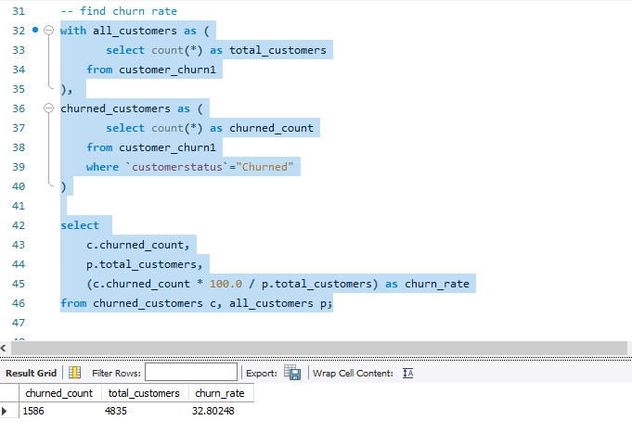

**Ques2. Find the average age of churned customers**

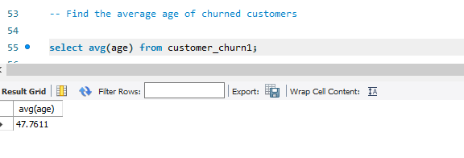

**Ques3.** Discover the most common contract types among churned customers

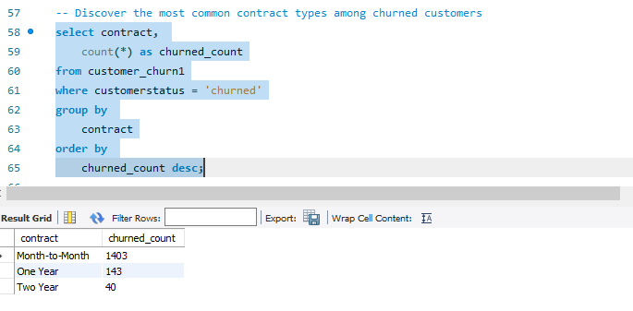

**Ques4.** Analyze the distribution of monthly charges among churned customers

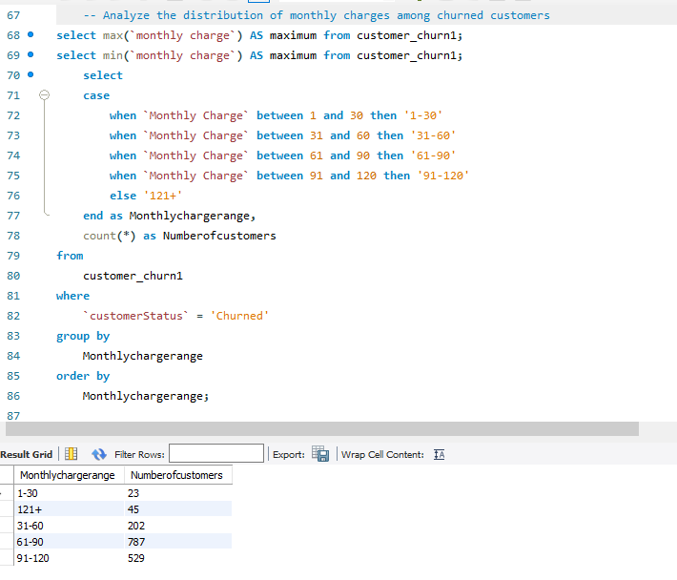

**Ques5.** Create a query to identify the contract types that are most prone to churn

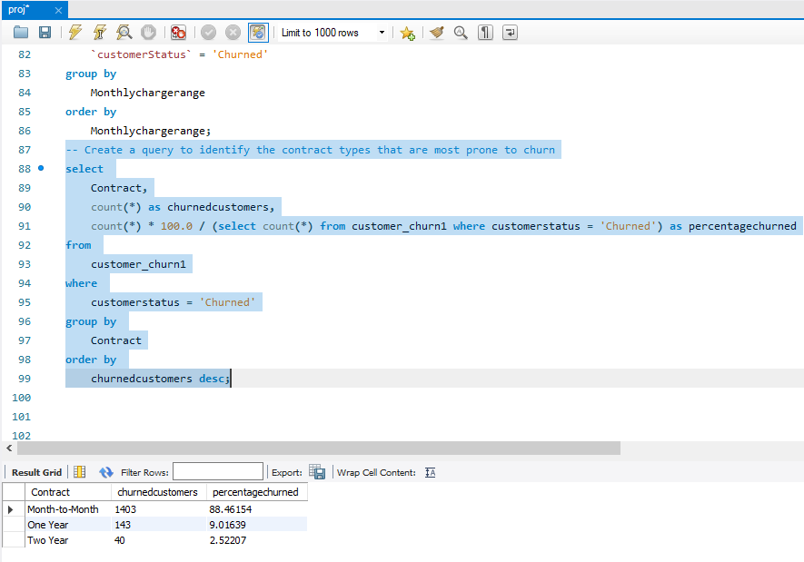

**Ques6.** Identify customers with high total charges who have churned

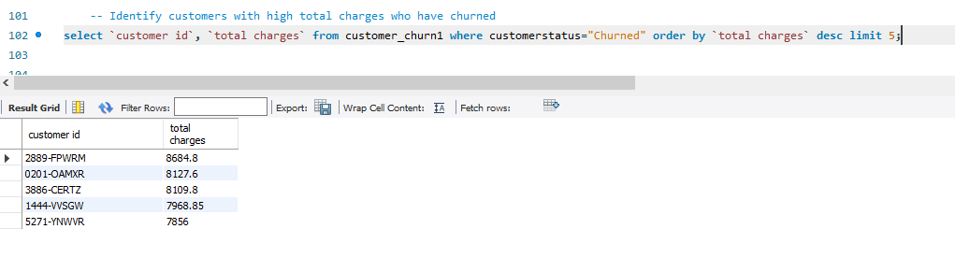

**Ques7.** Calculate the total charges distribution for churned and non-churned customers

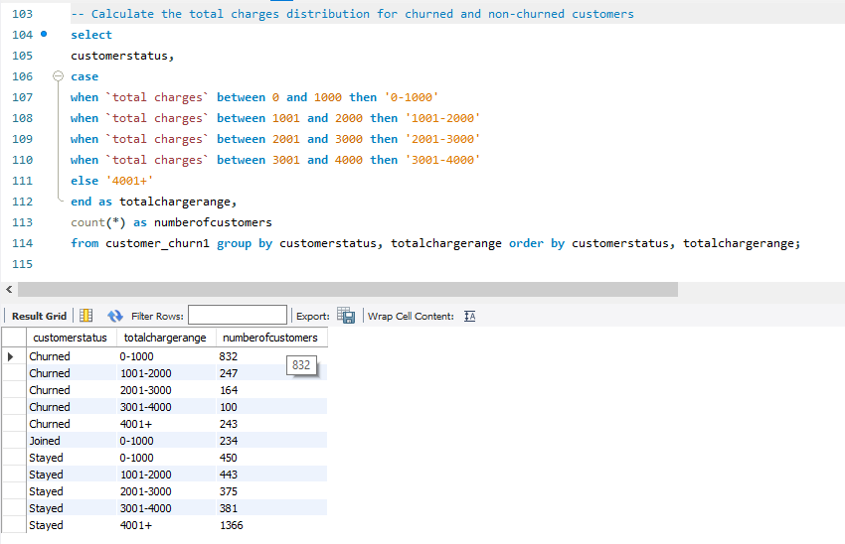

**Ques8.** Calculate the average monthly charges for different contract types among churned customers

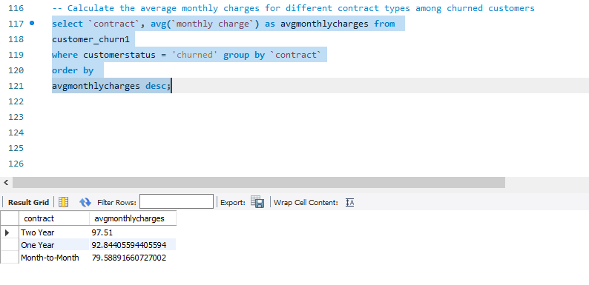

**Ques9.** Identify customers who have both online security and online backup services and have not churned

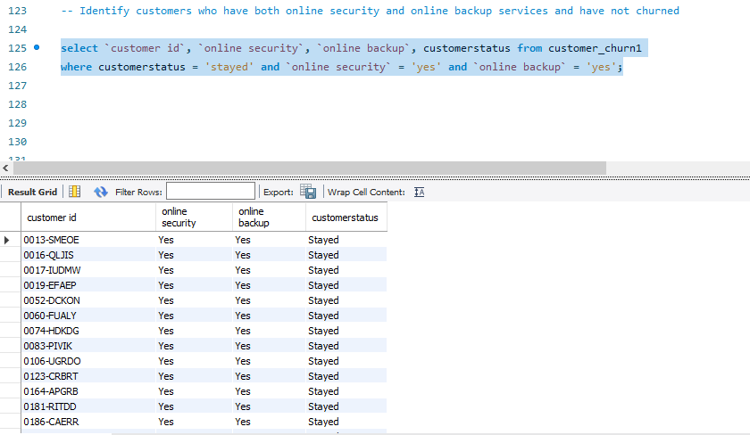

**Ques10.** Determine the most common combinations of services among churned customers

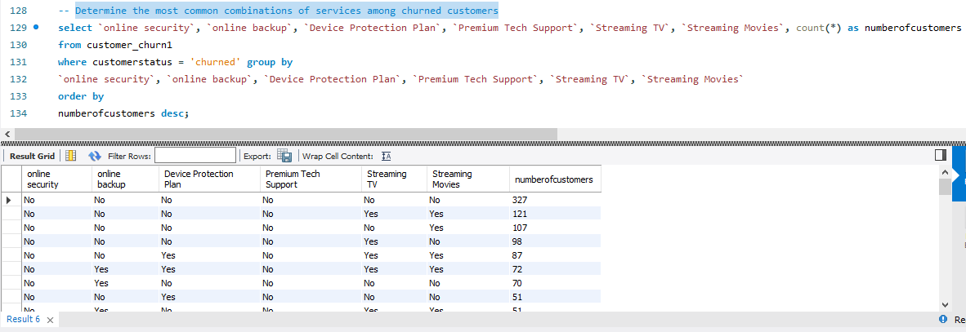

**Ques11.** Identify the average total charges for customers grouped by gender and marital status

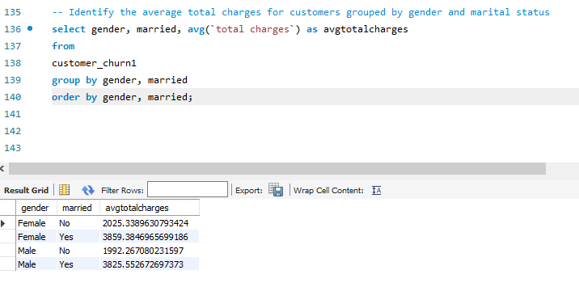

**Ques12.** Calculate the average monthly charges for different age groups among churned customers

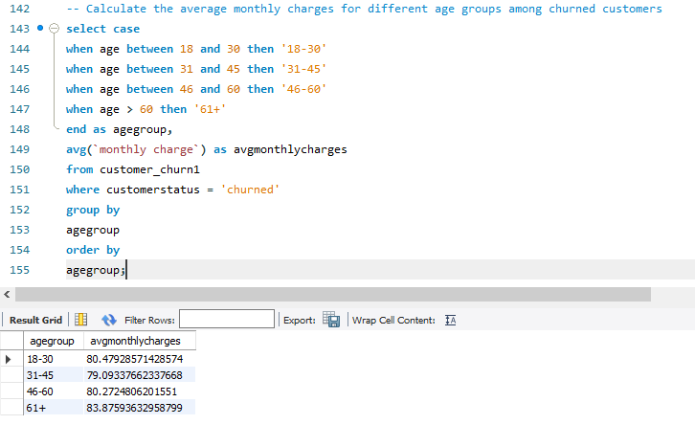

**Ques13.** Determine the average age and total charges for customers with multiple lines and online backup

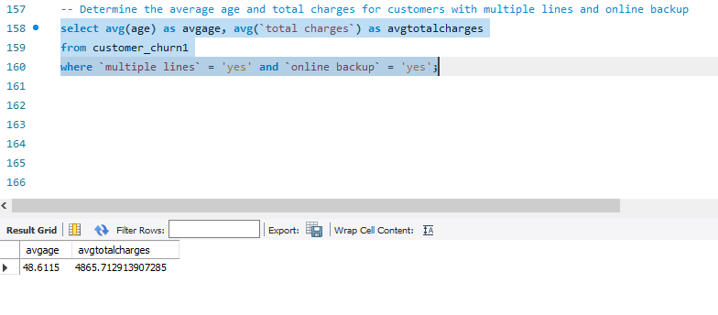

**Ques14.** Identify the contract types with the highest churn rate among senior citizens (age 65 and over)

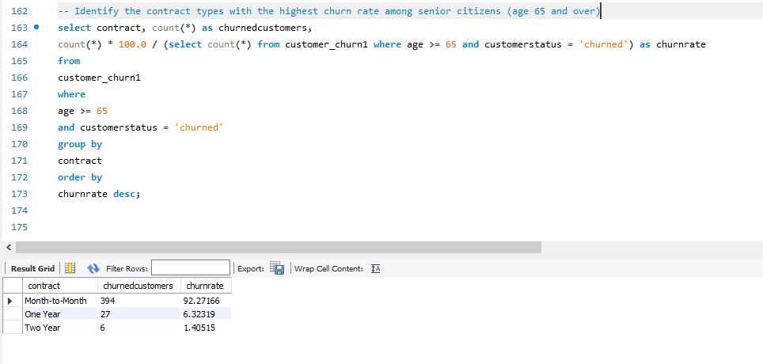

**Ques15.** Calculate the average monthly charges for customers who have multiple lines and streaming TV

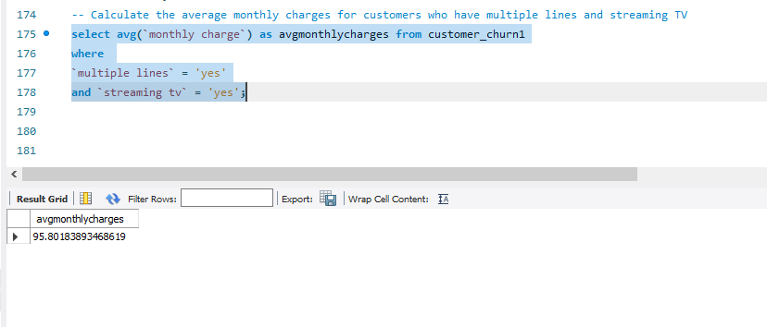

**Ques16.** Identify the customers who have churned and used the most online services

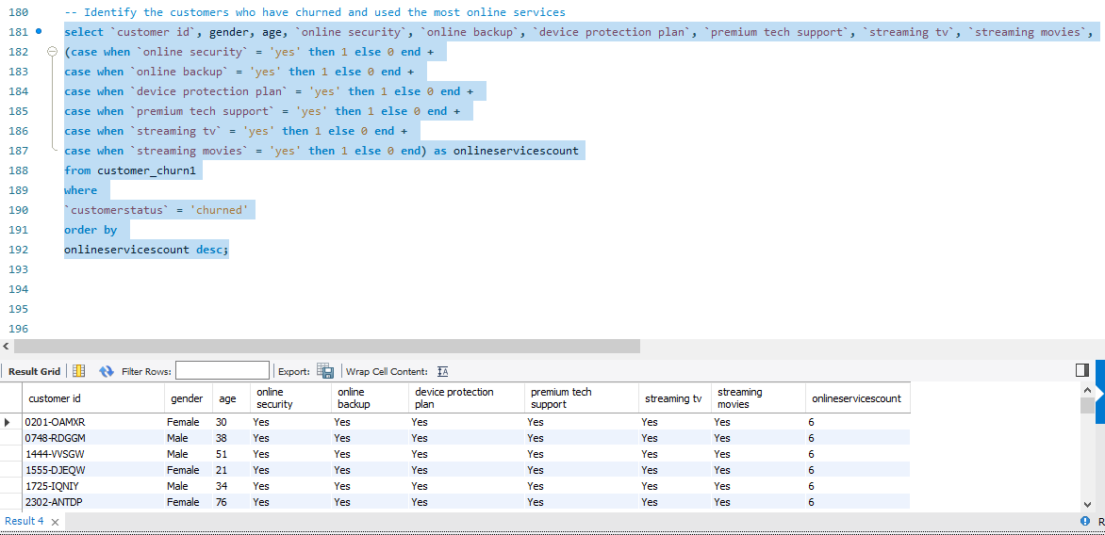

**Ques17.** Calculate the average age and total charges for customers with different combinations of streaming services

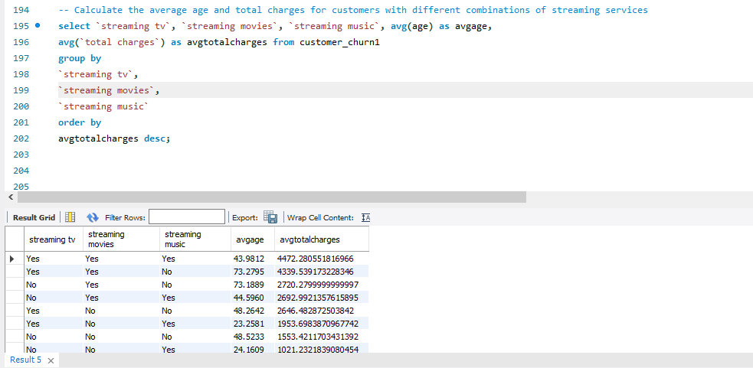

**Ques18.** Identify the gender distribution among customers who have churned and are on yearly contracts

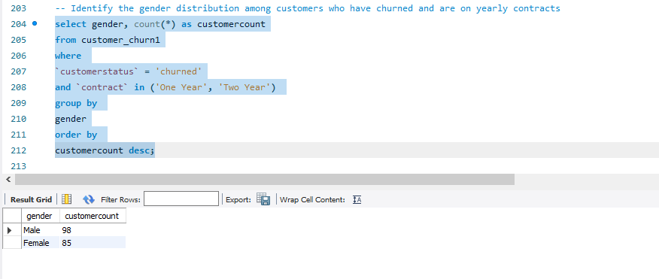

**Ques19.** Calculate the average monthly charges and total charges for customers who have churned, grouped by contract type and internet service type

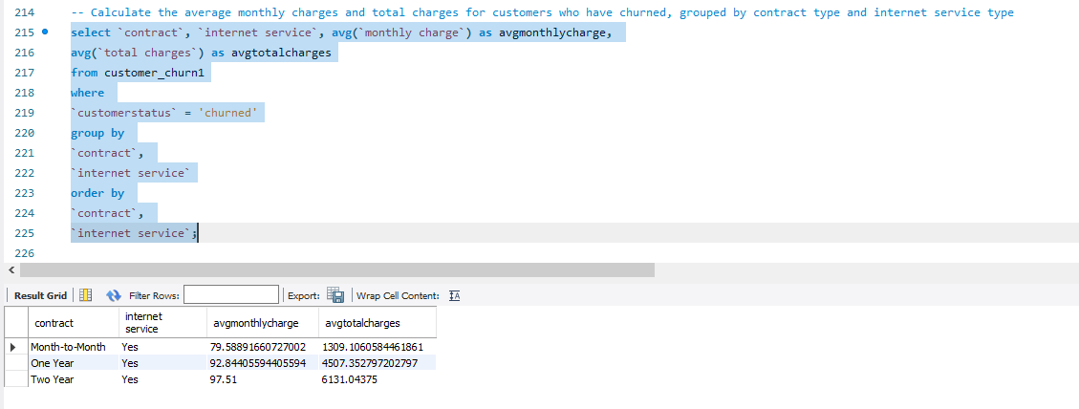

**Ques20.** Find the customers who have churned and are not using online services, and their average total charges

